Online Food Delivery Analysis: Data-Driven Business Insights
Domain
E-Commerce
Food & Beverage Industry
Logistics & Supply Chain
Customer Analytics
Business Intelligence

Data Collection
- Dataset consists of 100,000 online food delivery orders
- Data Set: https://drive.google.com/file/d/1ln_YbLXHZjah8c-zgrT_zacnfSwTB9ZE/view?usp=sharing
Project Deliverables:
- Source Code:
packages
import pandas as pd
import numpy as np
import datetime as dt
import matplotlib.pyplot as plt
import seaborn as sns
from scipy.stats import zscore

Data Loading
df=pd.read_csv('/content/ONINE_FOOD_DELIVERY_ANALYSIS.csv')
df
data understanding
pd.set_option('display.max_columns', None)
df.head(10)
To get overview
import data_profiling
from data_profiling import ProfileReport
EDA = ProfileReport(df,title='EDA')
EDA
df.isnull().sum()
Handling Missing Value
df['Customer_Age'].median()
age_median = df['Customer_Age'].median()
df['Customer_Age'] = df['Customer_Age'].fillna(age_median)
df['City']=df['City'].ffill()
df['Area']=df['Area'].ffill()
df['Cuisine_Type']=df['Cuisine_Type'].ffill()
df['Customer_Gender']=df['Customer_Gender'].ffill()
df['Order_Date']=df['Order_Date'].ffill()
ordertime_mode=df['Order_Time'].mode()
df['Order_Time'] = df['Order_Time'].ffill()
payment_mode=df['Payment_Mode'].mode()
df['Payment_Mode'] = df['Payment_Mode'].fillna(payment_mode)
checking outliers and Missing Value Handling
df['Delivery_Rating'].unique()
drating_median=df['Delivery_Rating'].median()
df['Delivery_Rating'] = df['Delivery_Rating'].fillna(drating_median)
df['Peak_Hour'].unique()
df['Peak_Hour']=df['Peak_Hour'].ffill()
df['Cancellation_Reason'].unique()
df.loc[
(df['Cancellation_Reason'].isnull()) & (df['Delivery_Time_Min'] >120.0 ) & (df['Order_Status']=='Cancelled'),
'Cancellation_Reason',
] = 'Late Delivery'
((df['Order_Status']=='Cancelled')&(df['Cancellation_Reason'].isna())).sum()
df.loc[df['Delivery_Time_Min'].notna() & (df['Payment_Mode'] == 'COD') & (df['Order_Status'] == 'Cancelled') & df['Cancellation_Reason'].isna(), 'Cancellation_Reason'] = 'Customer Cancelled'
df.loc[(df['Order_Status'] == 'Cancelled') & df['Cancellation_Reason'].isna() & df['Delivery_Time_Min'].isna(), 'Cancellation_Reason'] = 'Restaurant Issue'
df.loc[(df['Order_Status'] == 'Cancelled') & df['Cancellation_Reason'].isna() & df['Delivery_Time_Min'].notna(), 'Cancellation_Reason'] = 'Customer Cancelled'
df.loc[df['Order_Status'] == 'Delivered', 'Cancellation_Reason'] = 'not applicable'

Using plots to understand spread and outliers for numerical data
df['Delivery_Time_Min'].plot(kind='kde')
<Axes: ylabel='Density'>
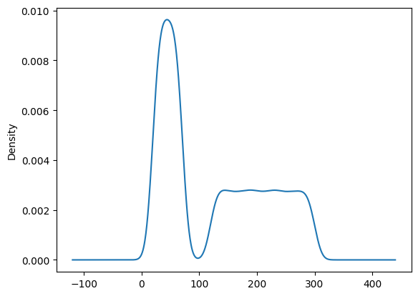

plt.figure(figsize=(10,5))
sns.boxplot(data=df, x='Delivery_Time_Min')
<Axes: xlabel='Delivery_Time_Min'>
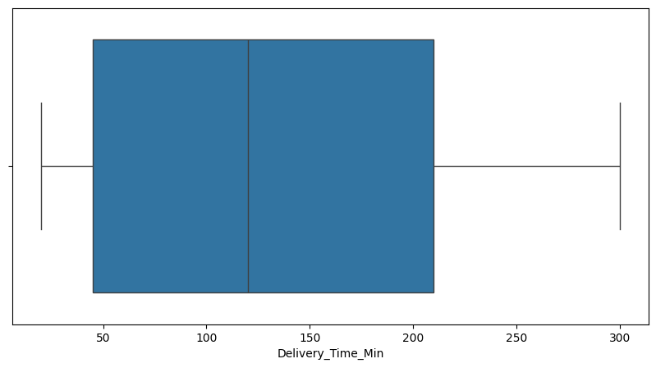
dtime_median=df['Delivery_Time_Min'].median()
df['Delivery_Time_Min'] = df['Delivery_Time_Min'].fillna(dtime_median)
dist_median=df['Distance_km'].median()
df['Distance_km'] = df['Distance_km'].fillna(dist_median)
restaurant_medians = df.groupby('Restaurant_ID')['Order_Value'].transform('median')
df.loc[df['Order_Status'] == 'Delivered', 'Order_Value'] = df.loc[df['Order_Status'] == 'Delivered', 'Order_Value'].fillna(restaurant_medians)
df.loc[df['Order_Status'] == 'Cancelled', 'Order_Value'] = df.loc[df['Order_Status'] == 'Cancelled', 'Order_Value'].fillna(0.0)
df.loc[df['Order_Status'] == 'Delivered', 'Discount_Applied'] = df.loc[df['Order_Status'] == 'Delivered', 'Discount_Applied'].fillna(0.00)
df.loc[df['Order_Status'] == 'Cancelled', 'Discount_Applied'] = df.loc[df['Order_Status'] == 'Cancelled', 'Discount_Applied'].fillna(0.00)
df.loc[df['Order_Status'] == 'Delivered', 'Final_Amount'] = df.loc[df['Order_Status'] == 'Delivered', 'Final_Amount'].fillna(df['Order_Value'] - df['Discount_Applied'])
df.loc[df['Order_Status'] == 'Cancelled', 'Final_Amount'] = df.loc[df['Order_Status'] == 'Cancelled', 'Final_Amount'].fillna(df['Order_Value'] - df['Discount_Applied'])
Payment_Mode=df['Payment_Mode'].mode()[0]
df['Payment_Mode'] = df['Payment_Mode'].fillna(Payment_Mode)
df['Profit_Margin'] = df['Profit_Margin'].clip(lower=0)
df['Final_Amount'] = (df['Order_Value'] - df['Discount_Applied']).clip(lower=0)
df['Restaurant_Rating'] = df['Restaurant_Rating'].apply(lambda x: 5.0 if x > 5.0 else x)
df['Price_Range'] = pd.cut(df['Order_Value'],
bins=[0, 1000, 2500, 4000, 5000],
labels=['Low (<1k)', 'Mid (1k-2.5k)', 'High (2.5k-4k)', 'Premium (4k+)'])
Plots
plt.figure(figsize=(10, 6))
sns.boxplot(data=df, x='Price_Range', y='Delivery_Time_Min', palette='Set2')

plt.title("Delivery Time Distribution Across Order Value Tiers", fontsize=14, pad=15)
plt.xlabel("Order Value Tiers", fontsize=12)
plt.ylabel("Delivery Time (Minutes)", fontsize=12)

plt.tight_layout()
plt.show()
/tmp/ipykernel_566/618626648.py:2: FutureWarning:

Passing `palette` without assigning `hue` is deprecated and will be removed in v0.14.0. Assign the `x` variable to `hue` and set `legend=False` for the same effect.

sns.boxplot(data=df, x='Price_Range', y='Delivery_Time_Min', palette='Set2')
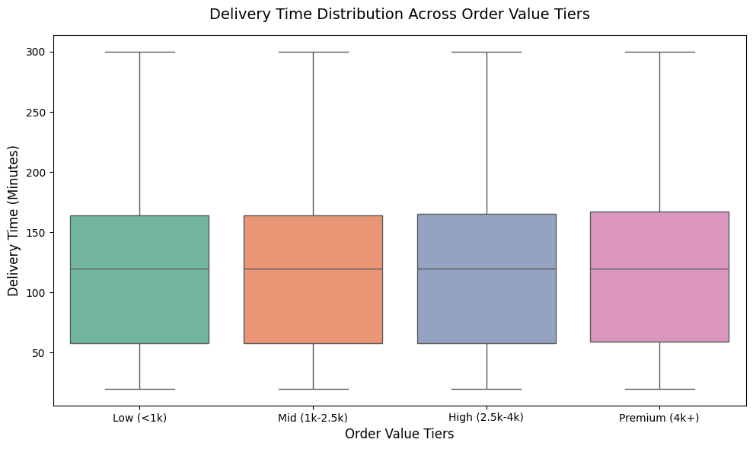
plt.figure(figsize=(12, 6))
sns.countplot(
data=df,
x='City',
hue='Cuisine_Type',
order=df['City'].value_counts().index,
palette='tab10'
)
plt.title("Popularity of Cuisines Across Different Cities", fontsize=14, pad=15, fontweight='bold')
plt.xlabel("City", fontsize=12)
plt.ylabel("Number of Orders", fontsize=12)
plt.legend(title="Cuisine Type", bbox_to_anchor=(1.05, 1), loc='upper left')

plt.tight_layout()
plt.show()
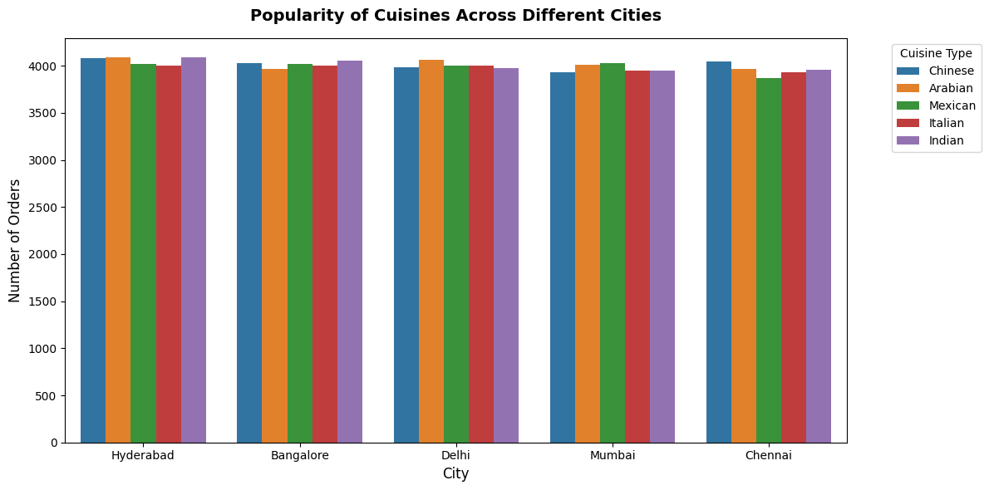
plt.figure(figsize=(9, 5))
sns.countplot(
data=df,
x='Order_Day',
hue='Peak_Hour',
palette='Set2',
order=['Weekday', 'Weekend']
)
plt.title("Day Classification", fontsize=12)
plt.title("Order Volume Split: Weekdays vs. Weekends", fontsize=14, pad=15, fontweight='bold')
plt.title("Total Orders Tracked", fontsize=12)
plt.legend(title="Is Peak Hour?", labels=["Off-Peak", "Peak Hour"])

plt.tight_layout()
plt.show()
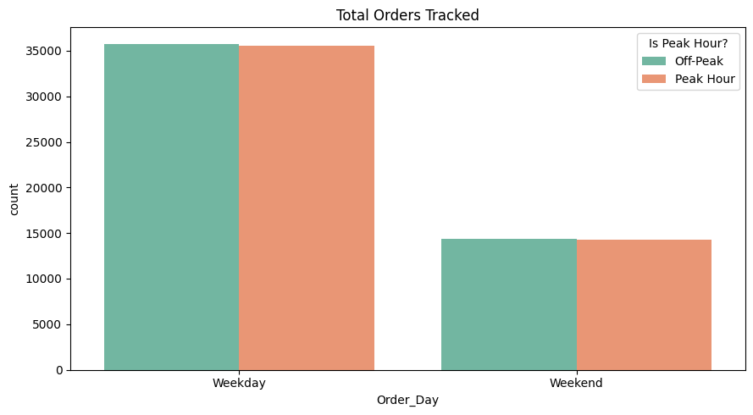
plt.figure(figsize=(10, 8))
sns.scatterplot(
data=df,
x='Distance_km',
y='Delivery_Time_Min',
s=100, # Size of the dots
alpha=0.6, # Transparancy (0 = invisible, 1 = completely solid)
color='#2b5c8f'
)
plt.title("Distance vs. Delivery Time Scatter Plot", fontsize=14, pad=15, fontweight='bold')
plt.xlabel("Distance traveled (km)", fontsize=11)
plt.ylabel("Delivery Time (Minutes)", fontsize=11)

plt.tight_layout()
plt.show()
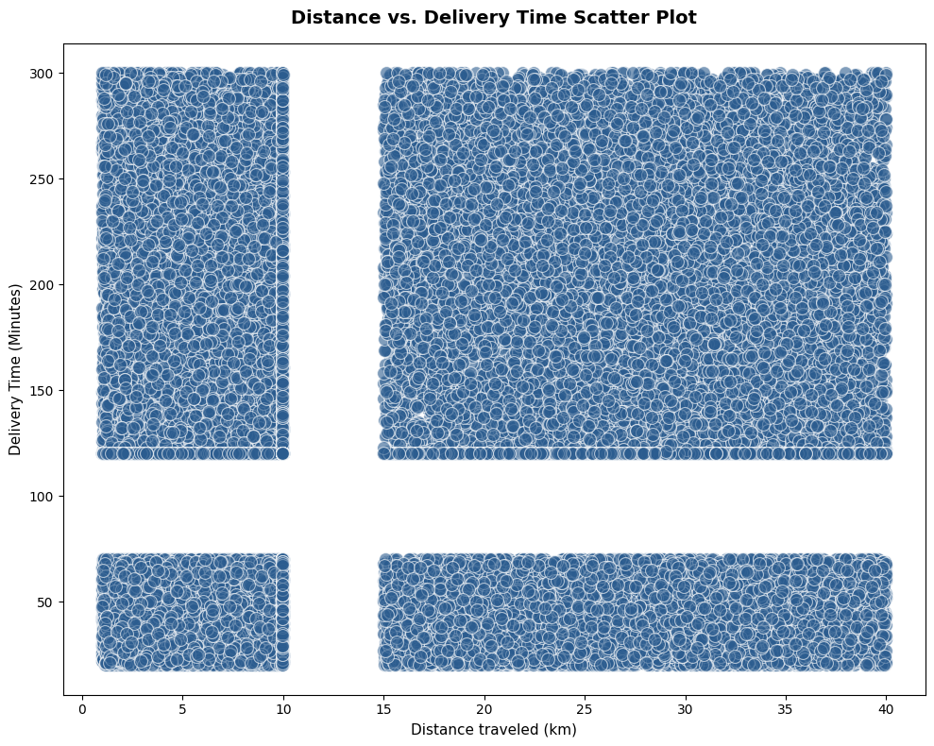
plt.figure(figsize=(12, 6))
plt.pie(x=df['Cancellation_Reason'].value_counts().values,
labels=df['Cancellation_Reason'].value_counts().index,
autopct='%1.1f%%')
plt.title("Cancellation_Reasont")
plt.show()
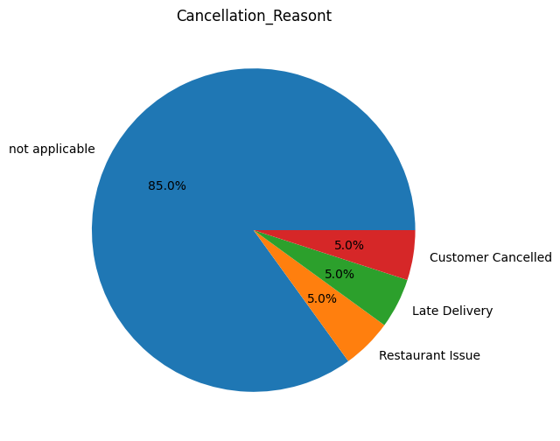
df['Delivery_Performance'] = pd.cut(
df['Delivery_Time_Min'],
bins=[0, 30, 45, 90, float('inf')],
labels=['Super Fast', 'On Time', 'Delayed', 'Severe Delay']
)
df['Age_Group'] = pd.cut(
df['Customer_Age'],
bins=[0, 25, 40, 60, 100],
labels=['Youth', 'Young Adults', 'Middle Aged', 'Senior']
)
Adding new column for data handling
df['Delivery_Performance'] = pd.cut(
df['Delivery_Time_Min'],
bins=[0, 30, 45, 90, float('inf')],
labels=['Super Fast', 'On Time', 'Delayed', 'Severe Delay']
)
df['Age_Group'] = pd.cut(
df['Customer_Age'],
bins=[0, 25, 40, 60, 100],
labels=['Youth', 'Young Adults', 'Middle Aged', 'Senior']
)
Connecting To Mysql
from sqlalchemy import create_engine

# Install pymysql if not already installed
!pip install pymysql

username = 'root'
password = 'Gayathri091022'
host = 'localhost'
port = 3306
database = 'mydb'
engine = create_engine(f'mysql+pymysql://{username}:{password}@{host}:{port}/{database}')
Mysql
Identify top-spending customers
select * from food_orders;
SELECT
Customer_ID,
City,
COUNT(Order_ID) AS total_orders,
SUM(Final_Amount) AS total_spent
FROM food_orders
WHERE Order_Status = 'Delivered'
AND Final_Amount IS NOT NULL
GROUP BY Customer_ID, City
ORDER BY total_spent DESC
LIMIT 10;
Analyze age group vs order value
SELECT
Age_Group,
COUNT(Order_ID) AS total_orders,
ROUND(AVG(Order_Value), 2) AS average_order_value,
ROUND(AVG(Final_Amount), 2) AS average_final_paid,
ROUND(SUM(Final_Amount), 2) AS total_revenue
FROM food_orders
WHERE Order_Status = 'Delivered'
GROUP BY Age_Group
ORDER BY average_order_value DESC;
Weekend vs weekday order patterns
SELECT
Order_Day,
COUNT(Order_ID) AS total_orders,
ROUND(COUNT(Order_ID) * 100.0 / SUM(COUNT(Order_ID)) OVER(), 2) AS order_percentage,
ROUND(AVG(Order_Value), 2) AS average_cart_value,
ROUND(AVG(Discount_Applied), 2) AS average_discount,
ROUND(AVG(Final_Amount), 2) AS average_final_spend,
ROUND(AVG(Delivery_Time_Min), 1) AS average_delivery_time_mins,
ROUND(AVG(Profit_Margin) * 100, 2) AS average_profit_margin_pct
FROM food_orders
WHERE Order_Status = 'Delivered'
GROUP BY Order_Day
ORDER BY total_orders DESC;
Monthly revenue trends
SELECT
DATE_FORMAT(STR_TO_DATE(Order_Date, '%m/%d/%Y'), '%Y-%m') AS order_month,
COUNT(Order_ID) AS total_orders,
ROUND(SUM(Final_Amount), 2) AS total_revenue,
ROUND(AVG(Final_Amount), 2) AS average_order_value,
ROUND(AVG(Profit_Margin) * 100, 2) AS average_profit_margin_pct
FROM food_orders
WHERE Order_Status = 'Delivered'
GROUP BY DATE_FORMAT(STR_TO_DATE(Order_Date, '%m/%d/%Y'), '%Y-%m')
ORDER BY order_month ASC;
Impact of discounts on profit
SELECT
CASE
WHEN Discount_Applied = 0 THEN 'No Discount (Full Price)'
WHEN Discount_Applied > 0 AND Discount_Applied <= 50 THEN 'Low Discount (<= 50)'
WHEN Discount_Applied > 50 AND Discount_Applied <= 200 THEN 'Medium Discount (51-200)'
ELSE 'High Discount (> 200)'
END AS discount_tier,
COUNT(Order_ID) AS total_orders,
ROUND(AVG(Order_Value), 2) AS avg_initial_cart_value,
ROUND(AVG(Discount_Applied), 2) AS avg_discount_given,
ROUND(AVG(Final_Amount), 2) AS avg_final_customer_paid,
ROUND(AVG(Profit_Margin) * 100, 2) AS average_profit_margin_pct,
ROUND(SUM(Order_Value * Profit_Margin), 2) AS estimated_total_profit
FROM food_orders
WHERE Order_Status = 'Delivered'
AND Discount_Applied IS NOT NULL
GROUP BY
CASE
WHEN Discount_Applied = 0 THEN 'No Discount (Full Price)'
WHEN Discount_Applied > 0 AND Discount_Applied <= 50 THEN 'Low Discount (<= 50)'
WHEN Discount_Applied > 50 AND Discount_Applied <= 200 THEN 'Medium Discount (51-200)'
ELSE 'High Discount (> 200)'
END
ORDER BY avg_discount_given ASC;
High-revenue cities and cuisines
SELECT
City,
Cuisine_Type,
COUNT(Order_ID) AS total_orders,
ROUND(SUM(Final_Amount), 2) AS total_revenue,
ROUND(AVG(Final_Amount), 2) AS average_order_value
FROM food_orders
WHERE Order_Status = 'Delivered'
AND City IS NOT NULL
AND Cuisine_Type IS NOT NULL
GROUP BY City, Cuisine_Type
ORDER BY total_revenue DESC
LIMIT 10;
Average delivery time by city
SELECT
City,
COUNT(Order_ID) AS total_orders,
ROUND(AVG(Delivery_Time_Min), 1) AS avg_delivery_time_mins,
ROUND(AVG(Distance_km), 2) AS avg_distance_km
FROM food_orders
WHERE Order_Status = 'Delivered'
AND City IS NOT NULL
AND Delivery_Time_Min IS NOT NULL
GROUP BY City
ORDER BY avg_delivery_time_mins DESC;
Distance vs delivery delay analysis
SELECT
CASE
WHEN Distance_km <= 5 THEN 'Short (0-5 km)'
WHEN Distance_km > 5 AND Distance_km <= 15 THEN 'Medium (5-15 km)'
WHEN Distance_km > 15 AND Distance_km <= 25 THEN 'Long (15-25 km)'
ELSE 'Very Long (>25 km)'
END AS distance_tier,
COUNT(Order_ID) AS total_orders,
ROUND(AVG(Delivery_Time_Min), 1) AS avg_delivery_time_mins,
MAX(Delivery_Performance) AS typical_performance_tier
FROM food_orders
WHERE Order_Status = 'Delivered'
AND Distance_km IS NOT NULL
AND Delivery_Time_Min IS NOT NULL
GROUP BY
CASE
WHEN Distance_km <= 5 THEN 'Short (0-5 km)'
WHEN Distance_km > 5 AND Distance_km <= 15 THEN 'Medium (5-15 km)'
WHEN Distance_km > 15 AND Distance_km <= 25 THEN 'Long (15-25 km)'
ELSE 'Very Long (>25 km)'
END
ORDER BY avg_delivery_time_mins ASC;
Delivery rating vs delivery time
SELECT
Delivery_Rating,
COUNT(Order_ID) AS total_orders,
ROUND(AVG(Delivery_Time_Min), 1) AS avg_delivery_time_mins,
ROUND(AVG(Distance_km), 2) AS avg_distance_km
FROM food_orders
WHERE Order_Status = 'Delivered'
GROUP BY Delivery_Rating
ORDER BY Delivery_Rating DESC;
Top-rated restaurants
SELECT
Restaurant_ID,
MAX(Cuisine_Type) AS cuisine,
COUNT(Order_ID) AS total_orders,
ROUND(AVG(Restaurant_Rating), 2) AS avg_restaurant_rating,
ROUND(SUM(Final_Amount), 2) AS total_revenue
FROM food_orders
WHERE Order_Status = 'Delivered'
GROUP BY Restaurant_ID
HAVING COUNT(Order_ID) >= 5
ORDER BY avg_restaurant_rating DESC, total_revenue DESC
LIMIT 10;
Cancellation rate by restaurant
SELECT
Restaurant_ID,
COUNT(Order_ID) AS total_orders_placed,
SUM(CASE WHEN Order_Status = 'Cancelled' THEN 1 ELSE 0 END) AS total_cancellations,
ROUND(
SUM(CASE WHEN Order_Status = 'Cancelled' THEN 1 ELSE 0 END) * 100.0 / COUNT(Order_ID),
2
) AS cancellation_rate_pct
FROM food_orders
GROUP BY Restaurant_ID
HAVING COUNT(Order_ID) >= 5
ORDER BY cancellation_rate_pct DESC;

Cuisine-wise performance
SELECT
Cuisine_Type,
COUNT(Order_ID) AS total_orders,
ROUND(SUM(Final_Amount), 2) AS total_revenue,
ROUND(AVG(Final_Amount), 2) AS average_order_value,
ROUND(AVG(Restaurant_Rating), 2) AS average_customer_rating
FROM food_orders
WHERE Order_Status = 'Delivered'
GROUP BY Cuisine_Type
ORDER BY total_revenue DESC;
Peak hour demand analysis
SELECT
CASE
WHEN Peak_Hour = TRUE THEN 'Peak Rush Hours'
ELSE 'Off-Peak Hours'
END AS operational_window,
COUNT(Order_ID) AS total_orders,
ROUND(AVG(Delivery_Time_Min), 1) AS avg_delivery_time_mins
FROM food_orders
WHERE Order_Status = 'Delivered'
GROUP BY Peak_Hour;
Payment mode preferences
SELECT
Payment_Mode,
COUNT(Order_ID) AS total_orders_placed,
ROUND(AVG(Final_Amount), 2) AS average_final_spend
FROM food_orders
GROUP BY Payment_Mode
ORDER BY total_orders_placed DESC;
Cancellation reason analysis
SELECT
Cancellation_Reason,
COUNT(Order_ID) AS total_cancelled_orders,
ROUND(SUM(Order_Value), 2) AS total_lost_revenue,
ROUND(AVG(Distance_km), 2) AS avg_distance_km,
MAX(City) AS hardest_hit_city
FROM food_orders
WHERE Order_Status = 'Cancelled'
AND Cancellation_Reason <> 'not applicable'
GROUP BY Cancellation_Reason
ORDER BY total_cancelled_orders DESC;

Outputs
Total_number_orders
Total_number_orders=df['Order_ID'].count()
Total_number_orders
100000
Total_revenue
Total_revenue=df['Order_Value'].sum()
Total_revenue
186639705.0
Average_order_value
Average_order_value=df['Order_Value'].mean()
Average_order_value
1866.39

Average_delivery_time
Average_delivery_time=df['Delivery_Time_Min'].mean()
Average_delivery_time
124.9
Average_delivery_rating
Average_delivery_rating=df['Delivery_Rating'].mean()
Average_delivery_rating
3
Cancellation_rate
cancellation_rate = (df['Order_Status'] == 'Cancelled').mean()
print(f"Cancellation Rate: {cancellation_rate:.2%}")
Cancellation Rate: 15.04%

POWER BI
Identify top-spending customers and Analyze age group vs order value

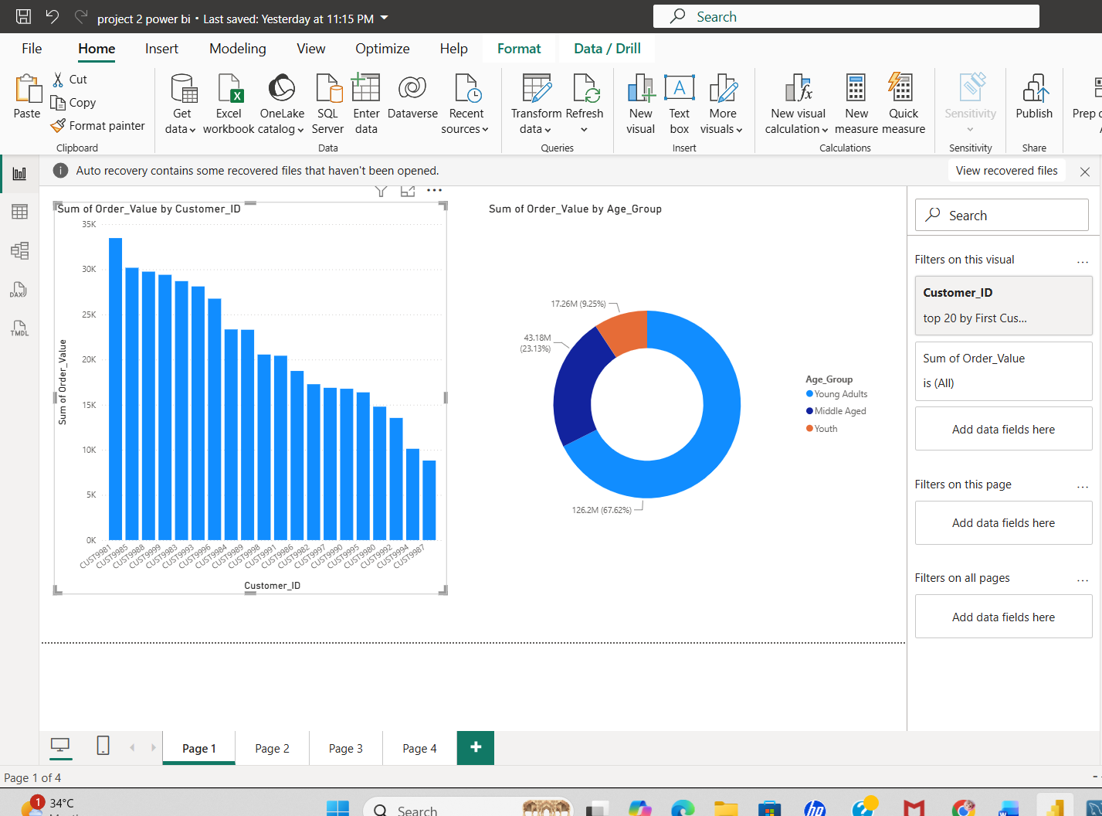

Weekend vs weekday order patterns
Monthly revenue trends
Impact of discounts on profit
High-revenue cities and cuisines

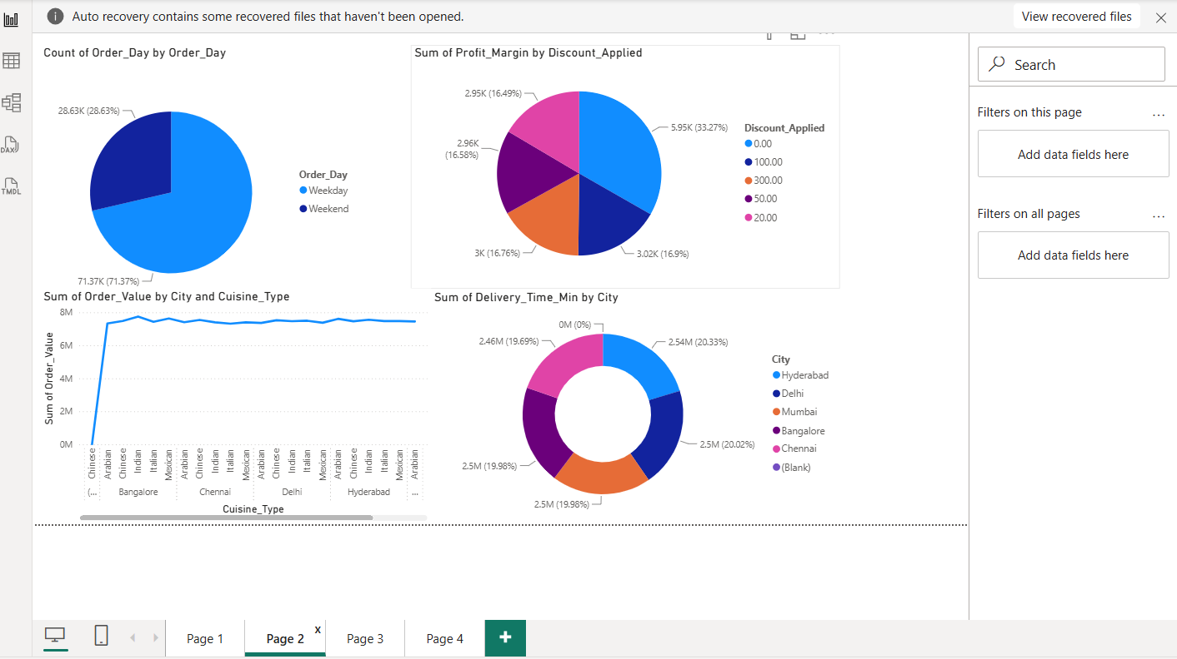

Average delivery time by city
Distance vs delivery delay analysis
Delivery rating vs delivery time
Top-rated restaurants

